|  |
| --- |
| Extract Method |

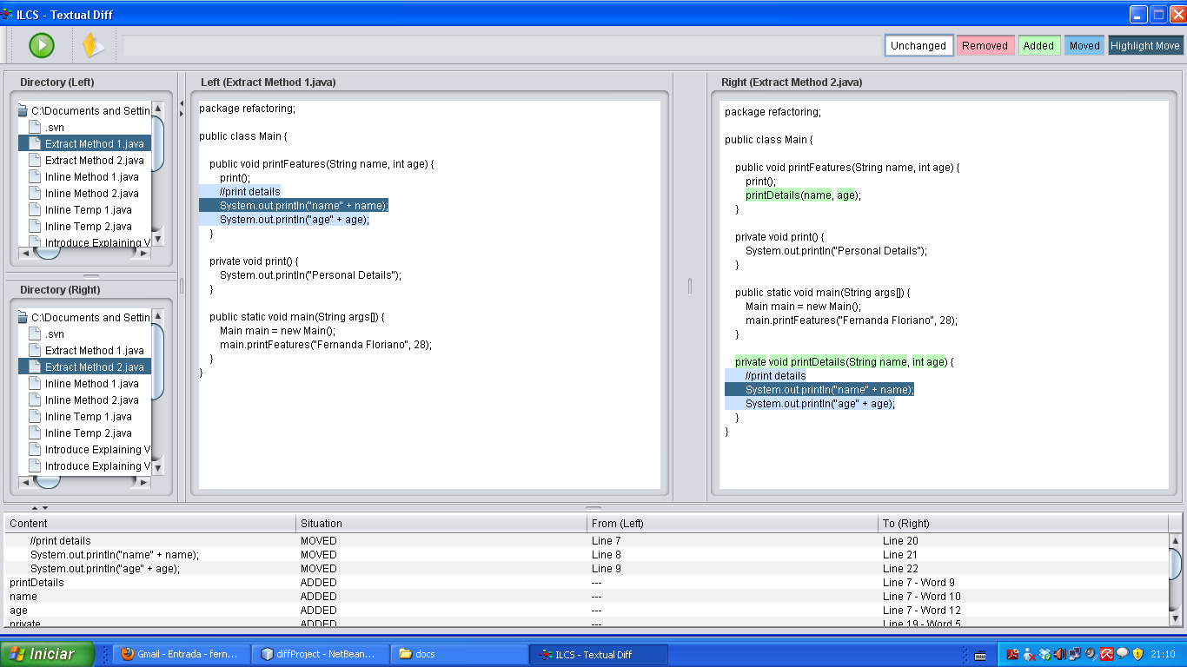

|  |
| --- |
| Inline Method |

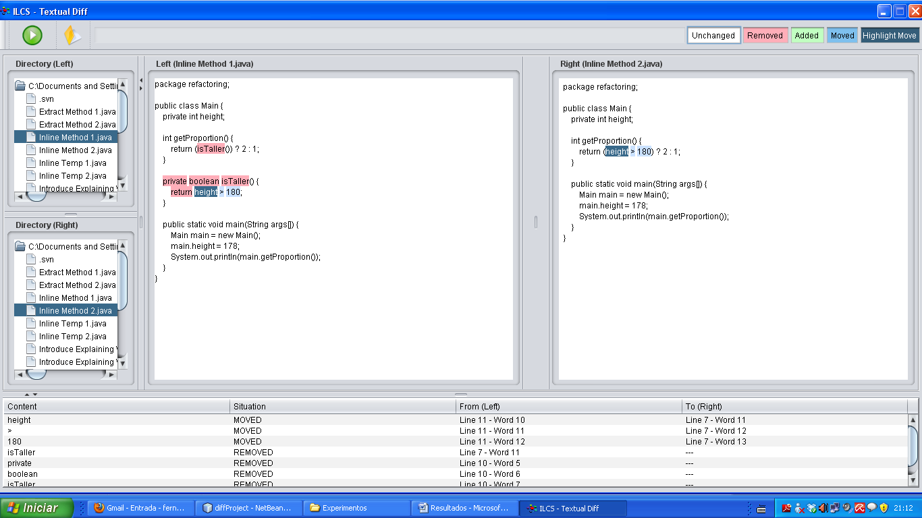

|  |
| --- |
| Inline Temp |

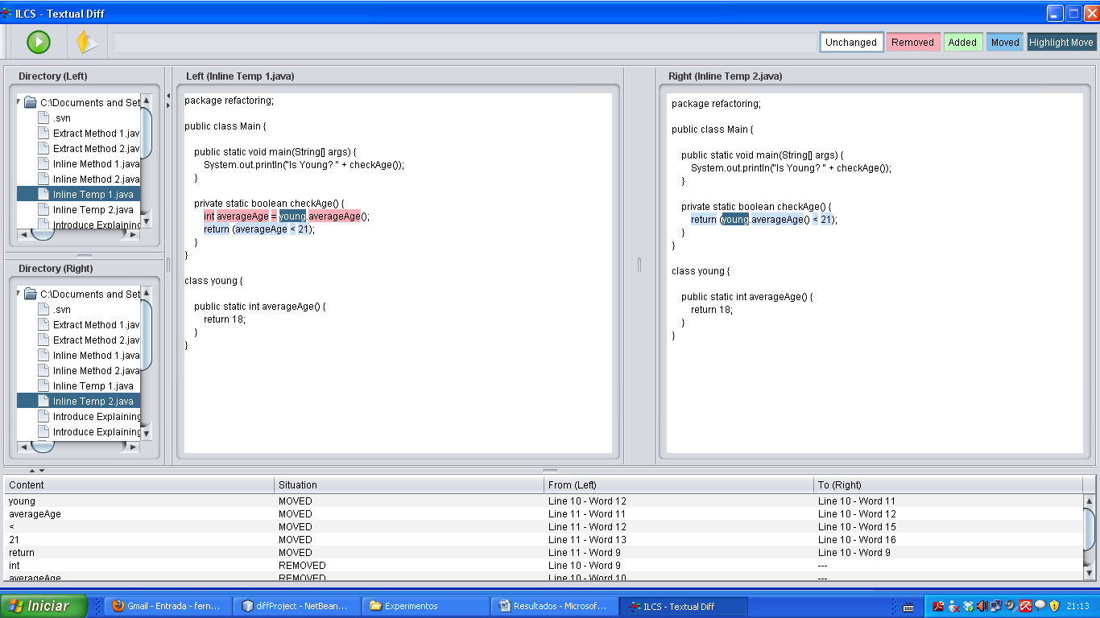

|  |
| --- |
| Introduce Explaining variable |

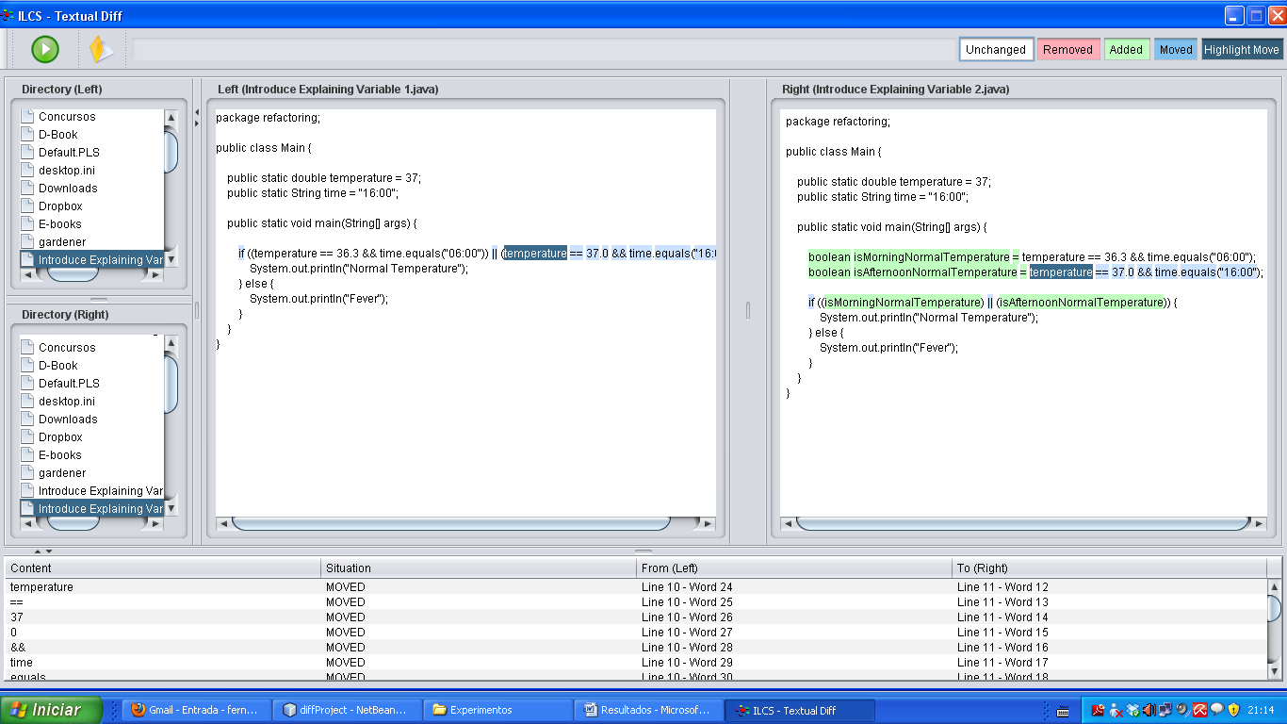

|  |
| --- |
| Remove assignments to parameters |

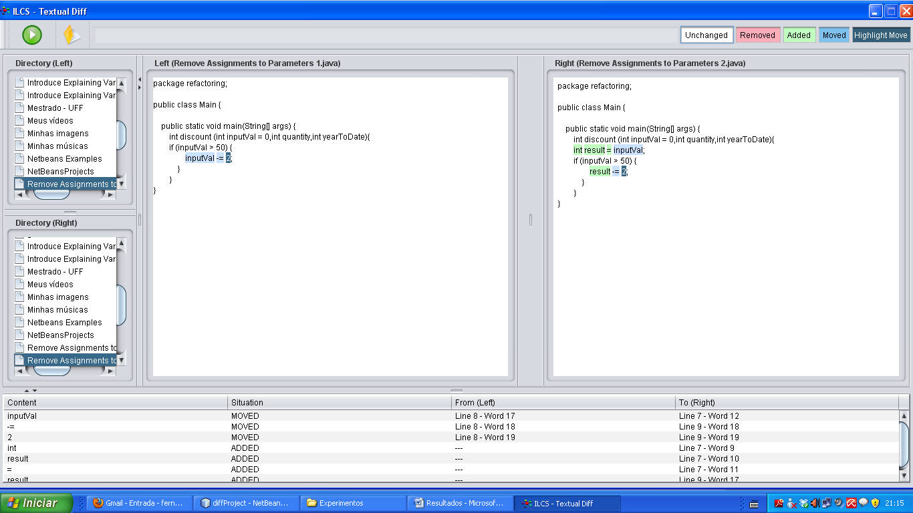

|  |
| --- |
| Replace Temp with query |

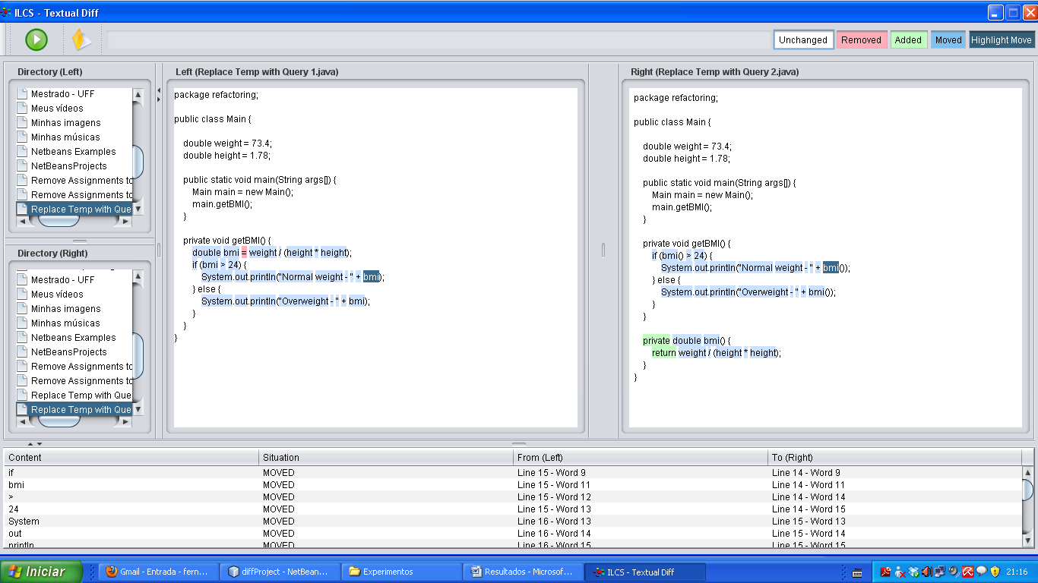

|  |
| --- |
| Split temporary variable |

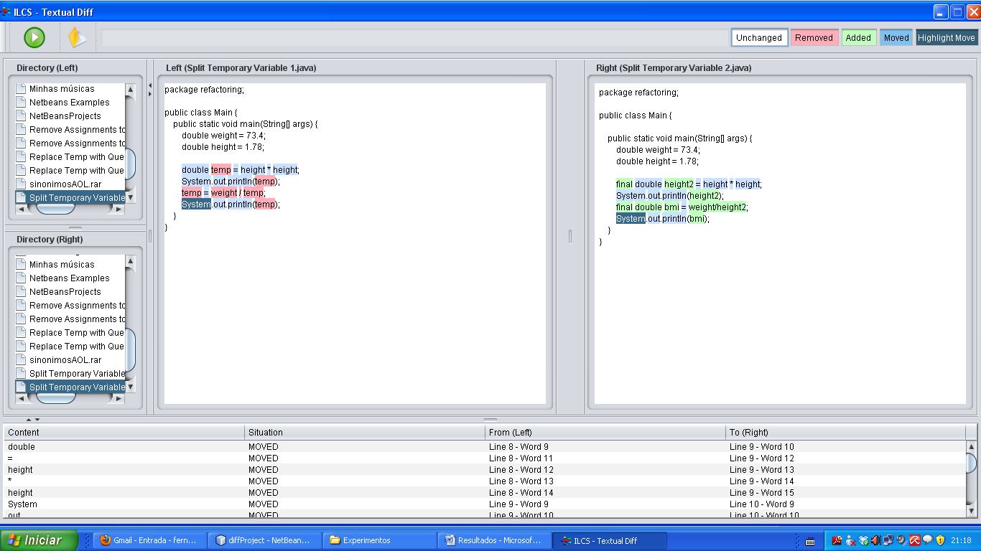

|  |
| --- |
| Substitute algorithm |

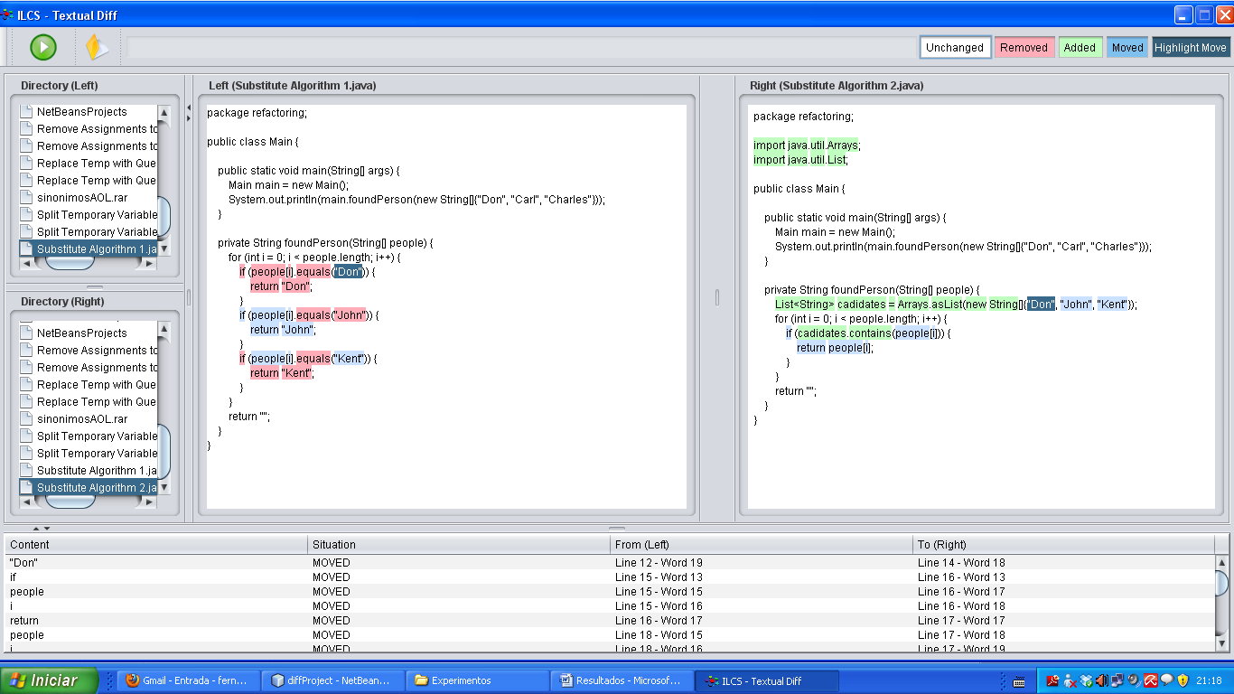

|  |
| --- |
| Replace Method with method object |